DATA ANALYSIS

- Background of Respondents
Location of Respondents
Location | Frequency | Percentage %
Jamestown | 95 | 80.5%
Accra | 5 | 4.2%
Bukom | 4 | 3.4%
Chorkor | 3 | 2.5%
Korle Gonno | 2 | 1.7%
Others | 9 | 7.6%
Total | 118 | 100.0%
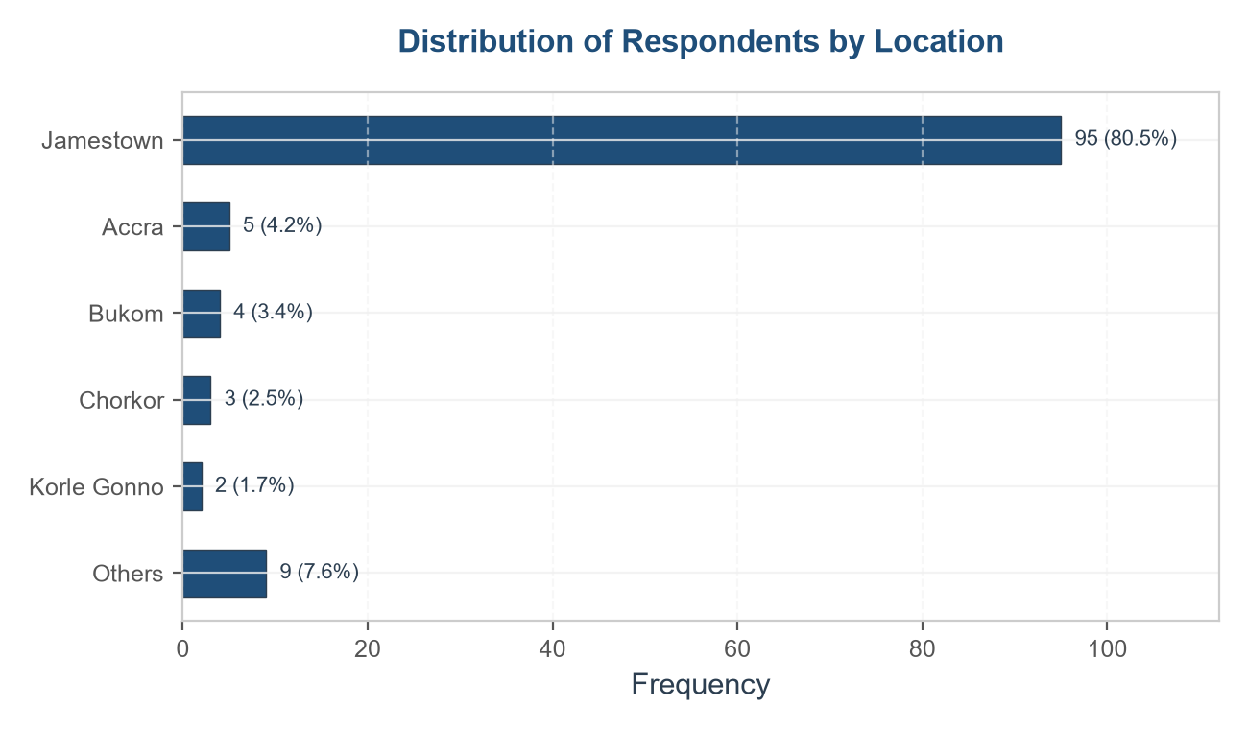

Gender of Respondents
Gender | Frequency | Percentage
Male | 115 | 97.5%
Female | 3 | 2.5%
Total | 118 | 100.0%
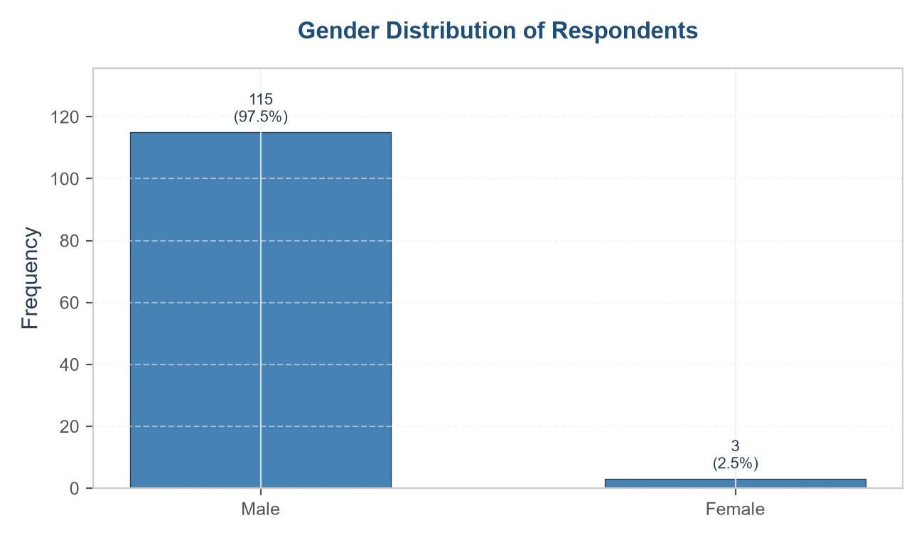

Age of Respondents
Age Group (Years) | Frequency | Percentage %
21 - 30 | 41 | 34.7%
31 - 40 | 44 | 37.3%
41 - 50 | 33 | 28.0%
51 - 60 | 0 | 0.0%
Above 60 | 0 | 0.0%
Total | 118 | 100.0%

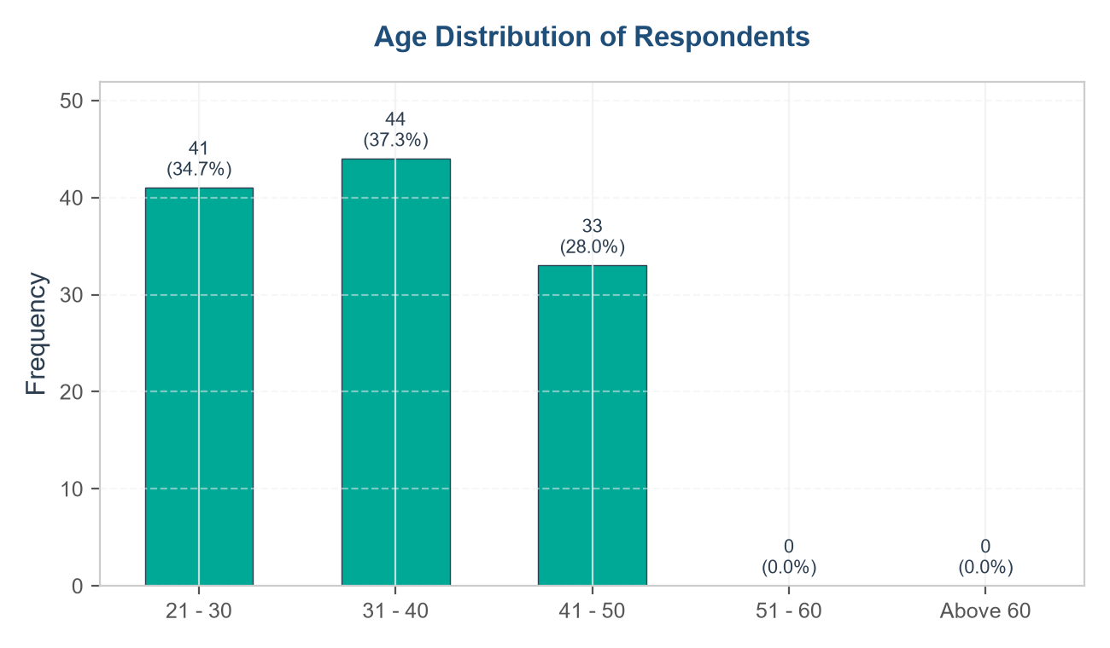
Marital Status of Respondents
Marital Status | Frequency | Percentage %
Single | 29 | 24.6%
Married | 19 | 16.1%
Divorced | 26 | 22.0%
Separated | 23 | 19.5%
Widowed | 21 | 17.8%
Total | 118 | 100.0%

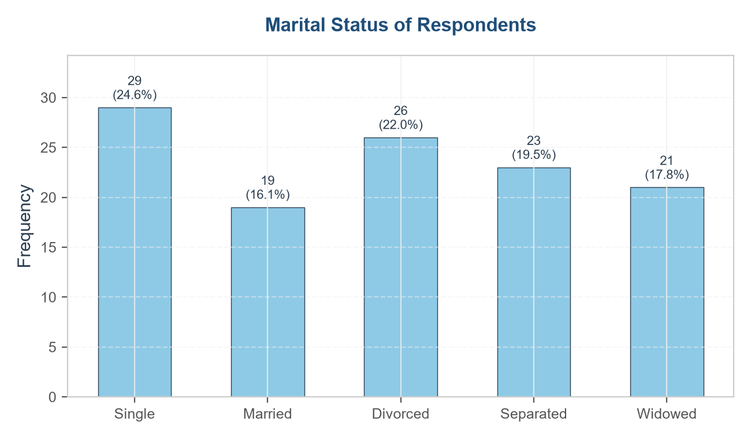
Level of Education of Respondents
Education level | Frequency | Percentage %
No formal education | 28 | 23.7%
Primary education | 38 | 32.2%
Junior High School | 24 | 20.3%
Senior High School | 14 | 11.9%
Vocational/Technical | 6 | 5.1%
Tertiary education | 8 | 6.8%
Total | 118 | 100.0%

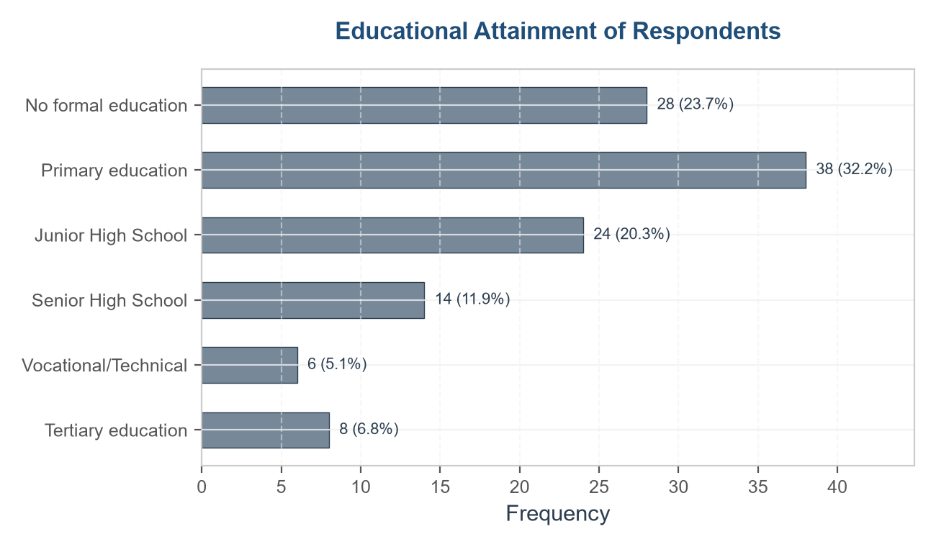
Religion of Respondents
Religion | Frequency | Percentage%
Christianity | 41 | 34.7%
Traditional religion | 41 | 34.7%
Islam | 17 | 14.4%
Other | 19 | 16.1%
Total | 118 | 100.0%

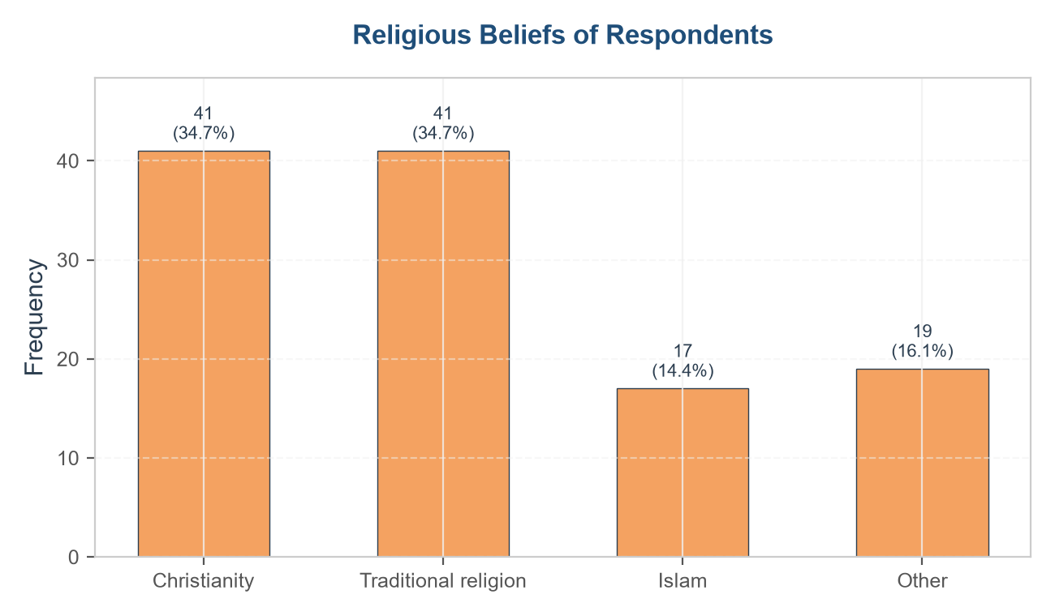
Household Size of Respondents
Household Size(Group) | Frequency | Percentage%
1 - 4 | 63 | 53.4%
5 - 7 | 54 | 45.8%
> 8 | 1 | 0.8%
Total | 118 | 100.0%

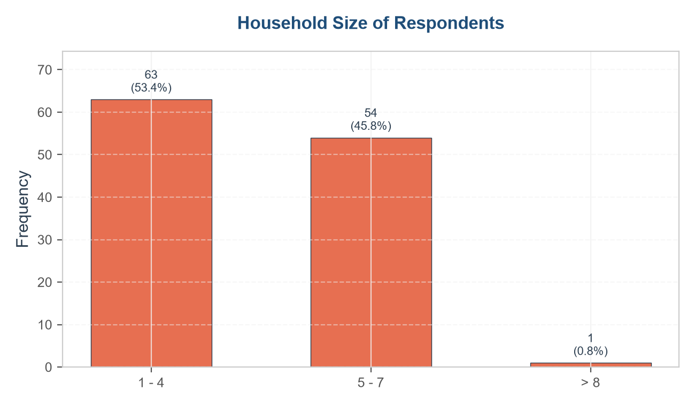
Major Occupation of Respondents
Major Occupation | Frequency | Percentage %
Fishing | 106 | 89.8%
Artisanship | 5 | 4.2%
Fish trading | 3 | 2.5%
Farming | 2 | 1.7%
Fish processing | 1 | 0.8%
Other | 1 | 0.8%
Total | 118 | 100.0%

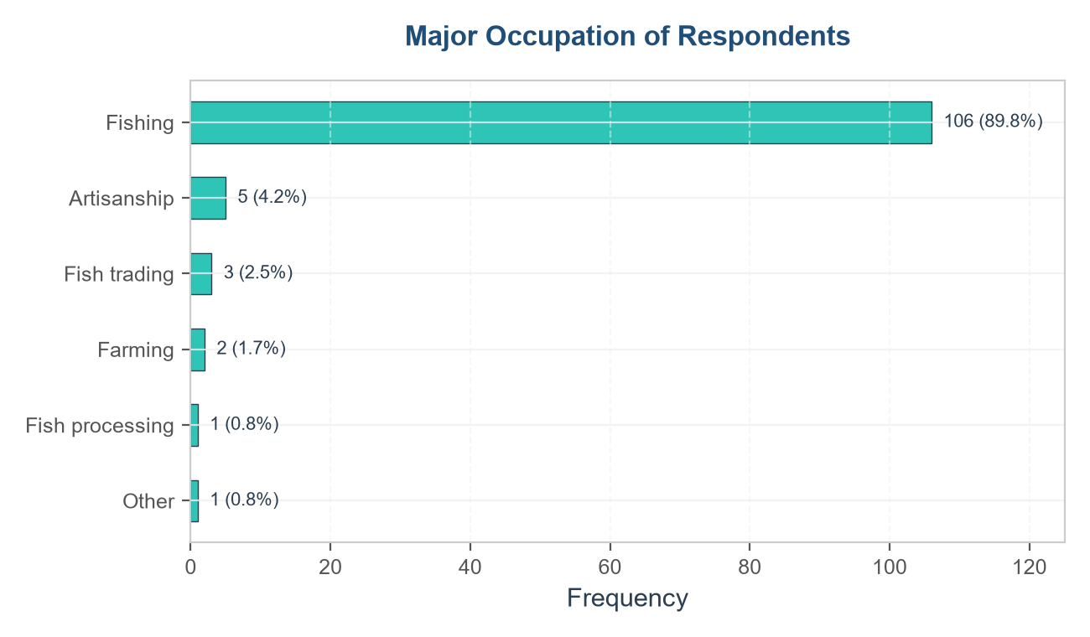
Secondary Occupation of Respondents
Secondary Occupation | Frequency | Percentage %
Trading | 18 | 15.3%
Casual labour | 16 | 13.6%
Processing | 13 | 11.0%
Farming | 5 | 4.2%
Transport business | 5 | 4.2%
Other | 2 | 1.7%
None | 59 | 50.0%
Total | 118 | 100.0%

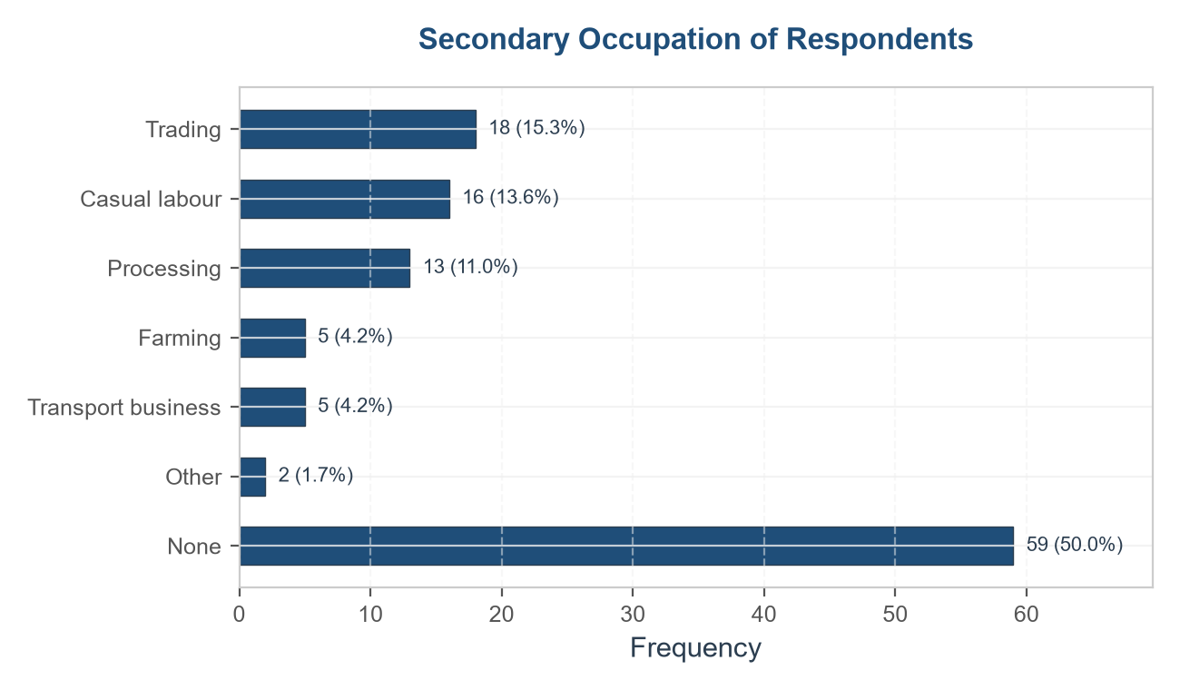
Canoe Ownership of Respondents
Canoe Ownership | Frequency | Percentage %
Yes | 72 | 61.0%
No | 46 | 39.0%
Total | 118 | 100.0%

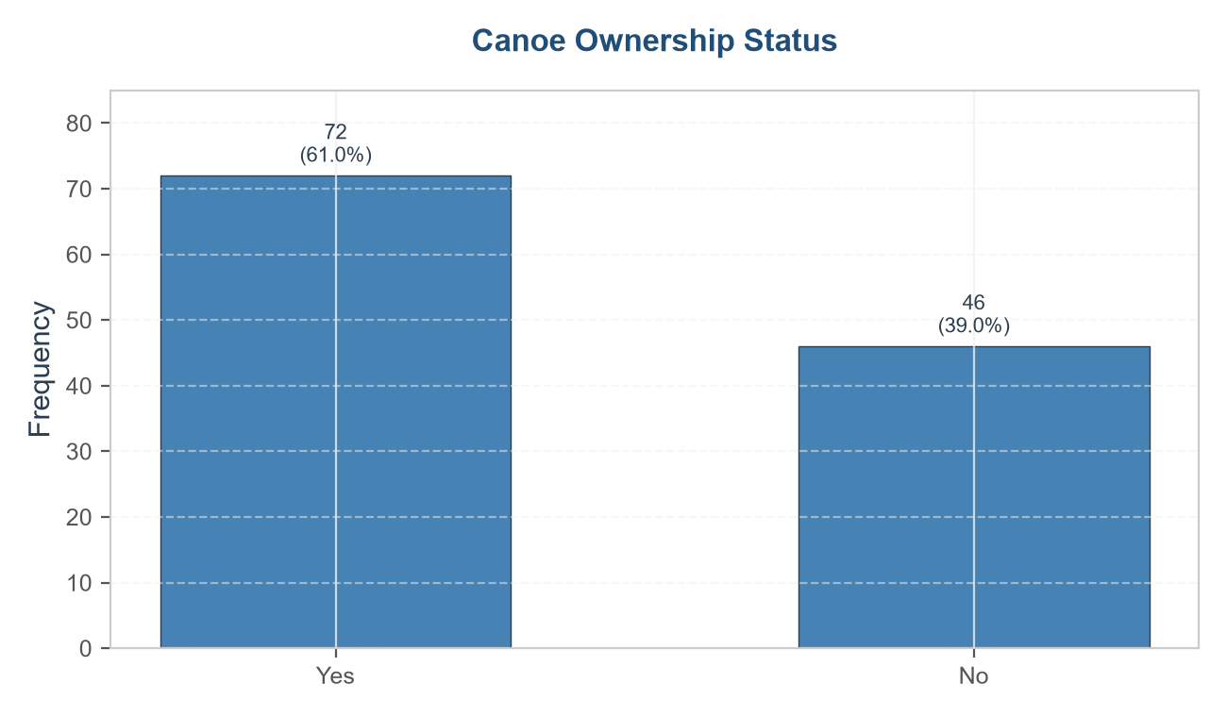
Average Monthly Household Income of Respondents
Income Bracket (GHS) | Frequency | Percentage %
< 3000 GHS | 8 | 6.8%
3000 - 3999 GHS | 41 | 34.7%
4000 - 4999 GHS | 37 | 31.4%
5000 - 5999 GHS | 22 | 18.6%
6000 GHS and above | 10 | 8.5%
Total | 118 | 100.0%

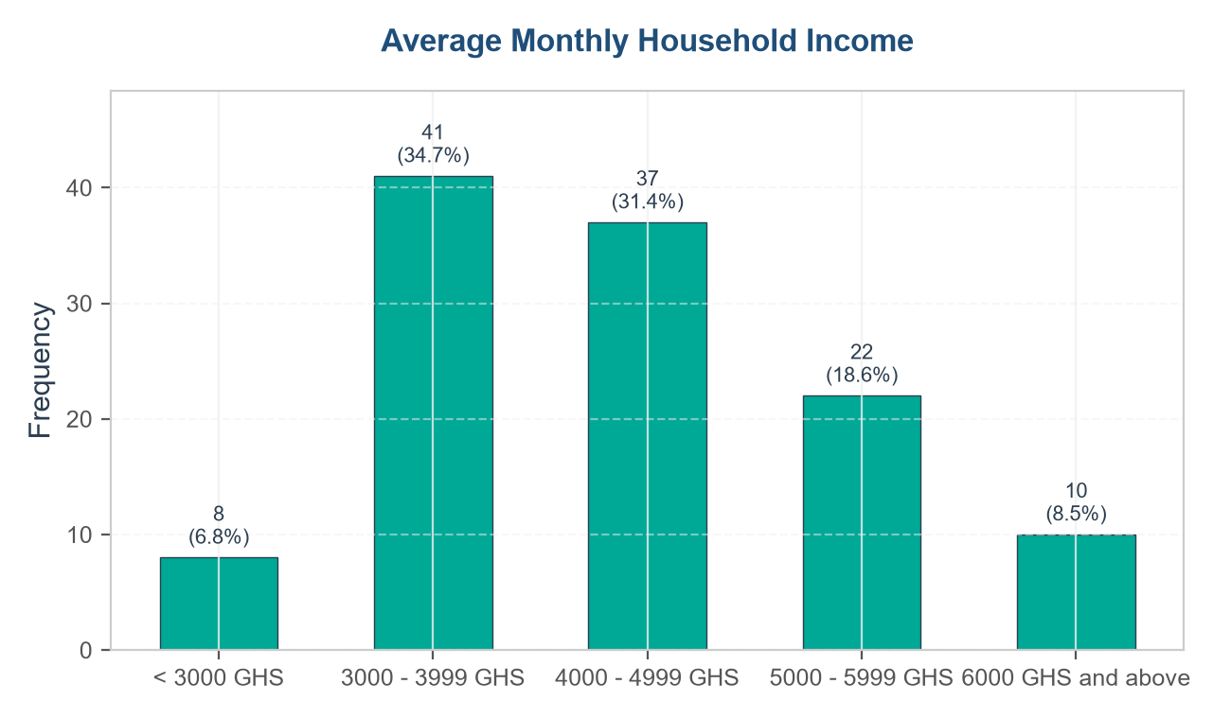

Employment Status in Fishing of Respondents
Employment Status | Frequency | Percentage %
Both owner and crew member | 53 | 44.9%
Crew member | 47 | 39.8%
Canoe owner | 18 | 15.3%
Total | 118 | 100.0%

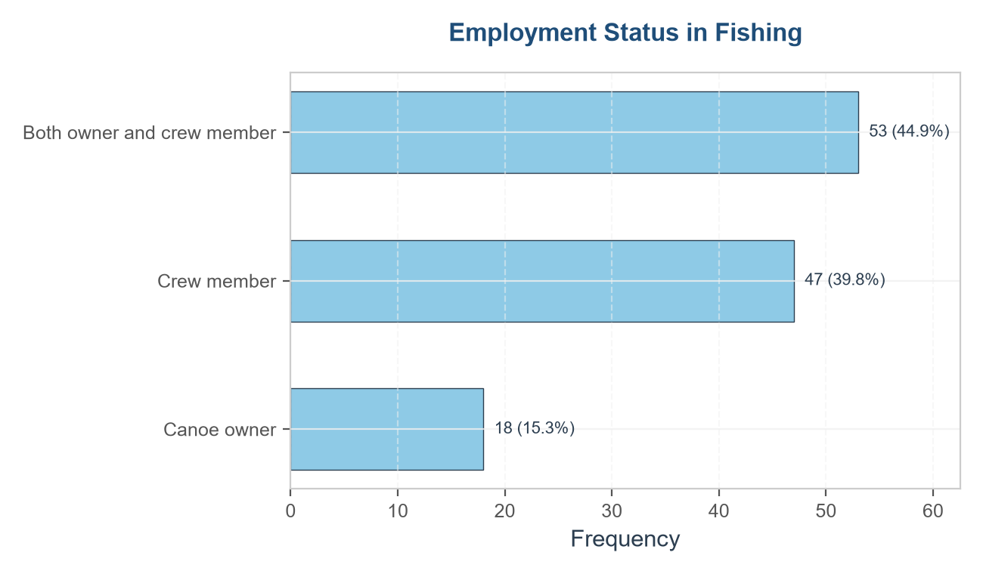
Associations/FBO of Respondents
Assoc/FBO | Frequency | Percentage
Yes | 87 | 73.7%
No | 31 | 26.3%
Total | 118 | 100.0%

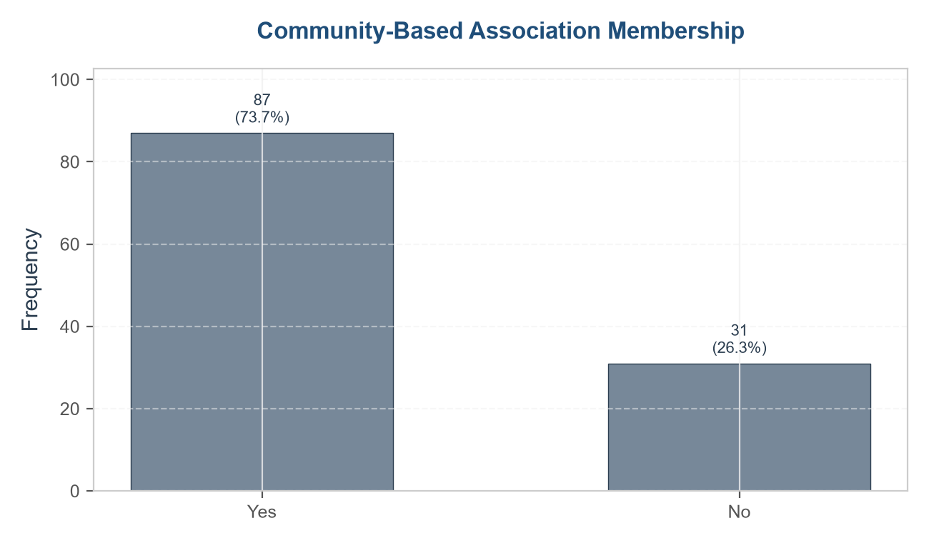

- Financial Characteristics of Respondents
Savings Status of Respondents
Saves Part of Income | Frequency | Percentage %
Yes | 56 | 47.5%
No | 62 | 52.5%
Total | 118 | 100.0%
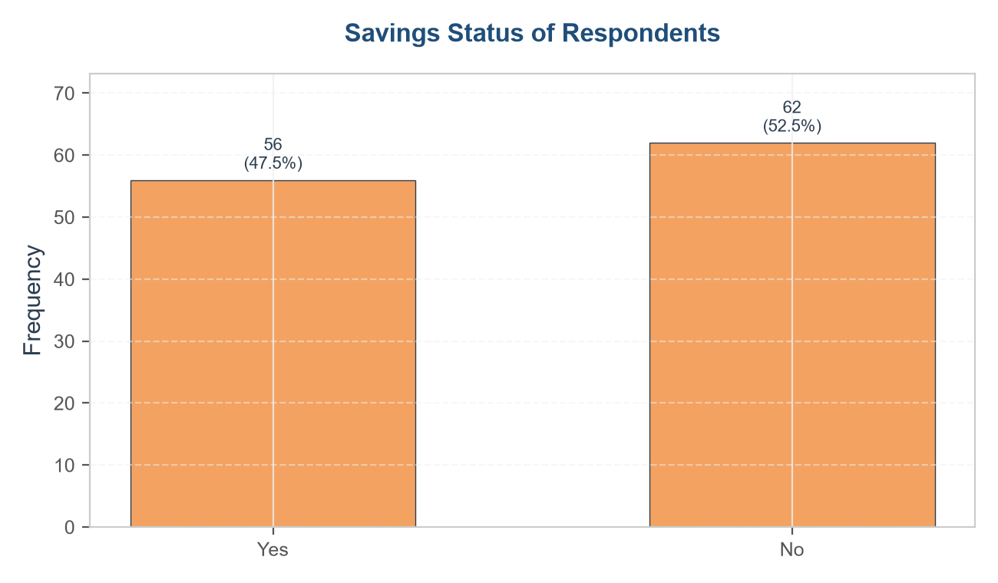

Reinvestment of Fishing Revenue
Reinvests in Fishing | Frequency | Percentage %
Yes | 100 | 84.7%
No | 18 | 15.3%
Total | 118 | 100.0%

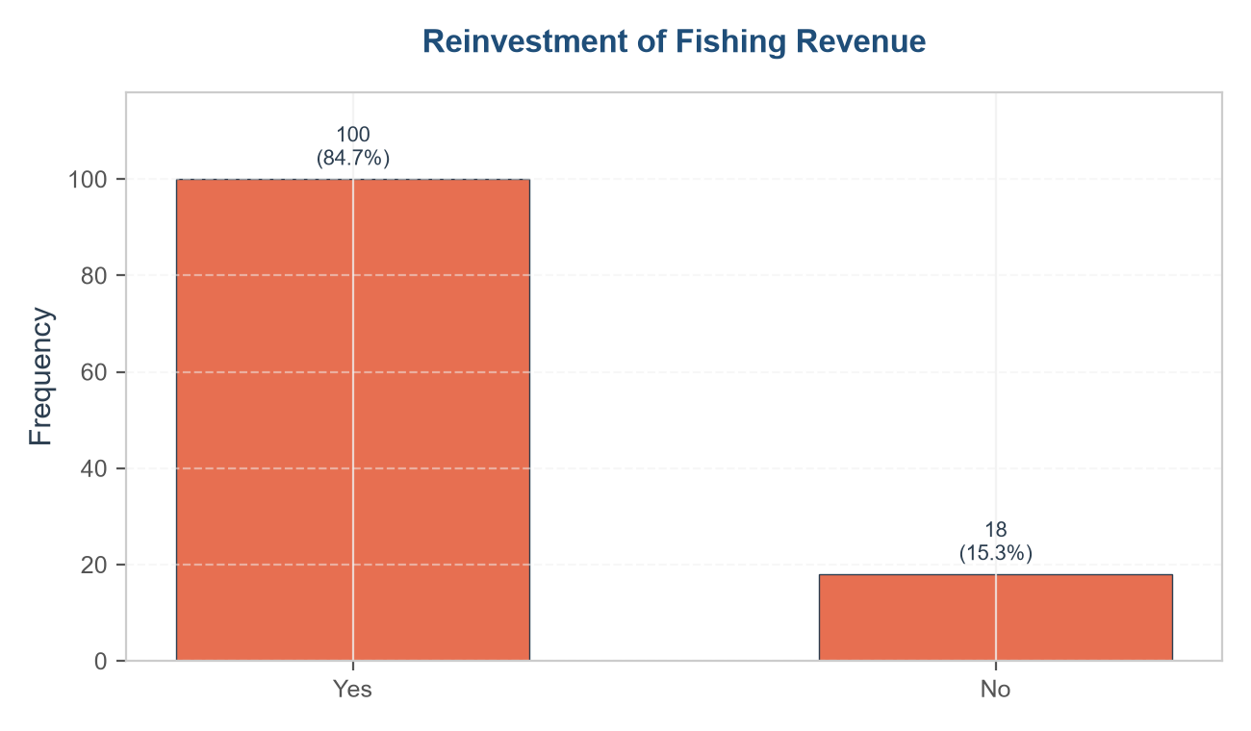
Type of Community Association Belonged To
Association Type | Frequency | Percentage %
Fisher association | 34 | 28.8%
Cooperative society | 30 | 25.4%
Fish processors association | 9 | 7.6%
Savings group | 9 | 7.6%
Religious association | 4 | 3.4%
Other | 1 | 0.8%
None | 31 | 26.3%
Total | 118 | 100.0%

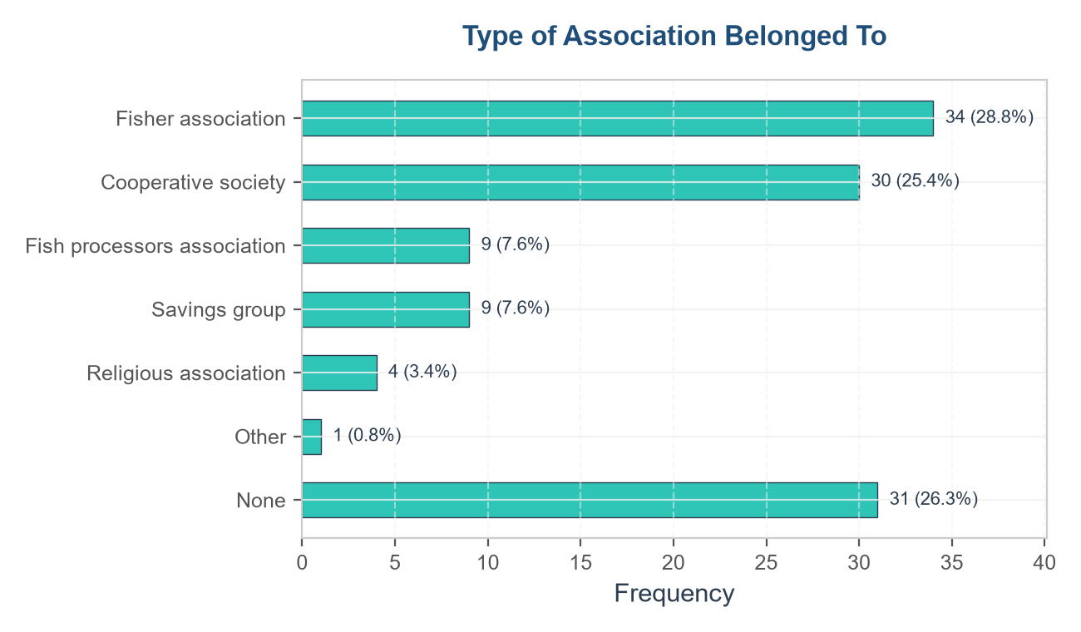
Average Weekly Expenditure on Fuel
Weekly Fuel Cost (GHS) | Frequency | Percentage %
< 500 GHS | 17 | 14.4%
500 - 699 GHS | 24 | 20.3%
700 - 899 GHS | 26 | 22.0%
900 GHS and above | 29 | 24.6%
Not Applicable | 22 | 18.6%
Total | 118 | 100.0%

Mean(GHS) | Median(GHS) | Minimum(GHS) | Maximum(GHS) | Standard Deviation
736.59 | 715.00 | 319.00 | 1,175.00 | 239.50

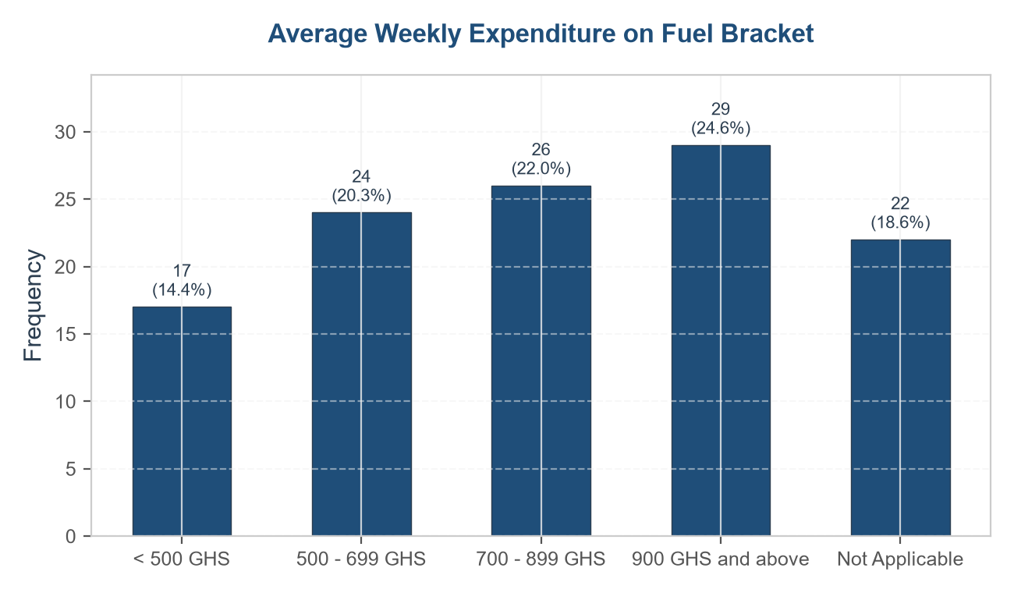

Rating of Fuel Price Increase Over the Years
Fuel Price Increase Rating | Frequency | Percentage %
Very high | 18 | 15.3%
High | 27 | 22.9%
Moderate | 28 | 23.7%
Low | 20 | 16.9%
Very low | 3 | 2.5%
N/A | 22 | 18.6%
Total | 118 | 100.0%

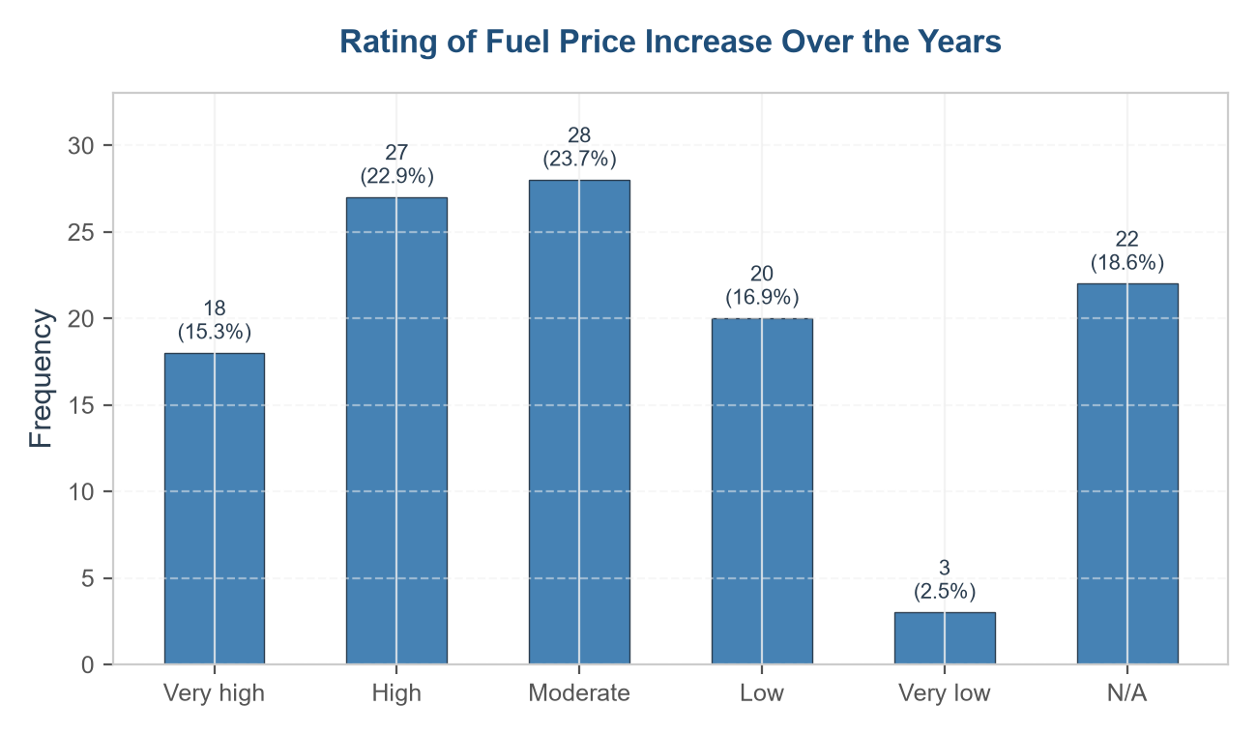

Frequency of Fuel Shortages Affecting Fishing
Fuel Shortage Frequency | Frequency | Percentage %
Very often | 9 | 7.6%
Often | 33 | 28.0%
Occasionally | 37 | 31.4%
Rarely | 7 | 5.9%
N/A | 32 | 27.1%
Total | 118 | 100.0%

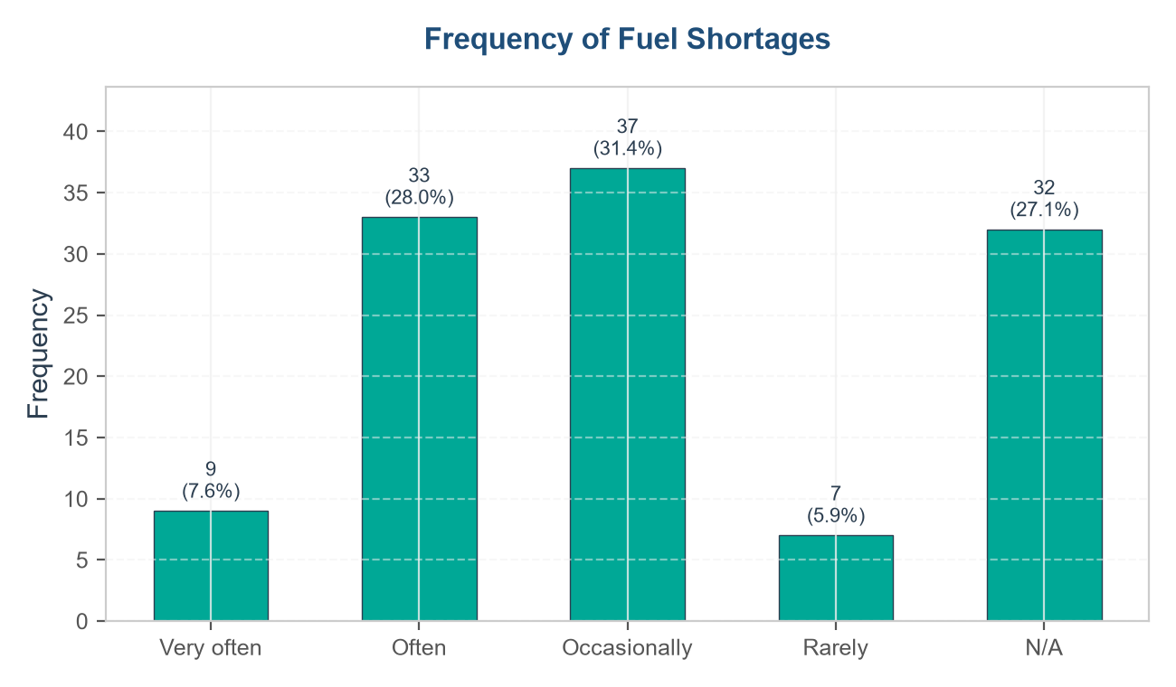

- Key Operational Challenges and Support
Fishing Experience and Capacity
Fishing Experience (Years) | Frequency | Percentage %
< 10 years | 30 | 25.4%
10 - 19 years | 46 | 39.0%
20 - 30 years | 42 | 35.6%
Total | 118 | 100.0%

Weekly Catch Bracket (kg) | Frequency | Percentage %
< 150 kg | 18 | 15.3%
150 - 249 kg | 41 | 34.7%
250 - 349 kg | 34 | 28.8%
350 kg and above | 25 | 21.2%
Total | 118 | 100.0%

Believes Cooperatives Help | Frequency | Percentage %
Yes | 95 | 80.5%
No | 23 | 19.5%
Total | 118 | 100.0%

Experience of Operational Challenges and Records
Variable | Yes Frequency (%) | No Frequency (%) | Total (n = 75)
Belong to community association | 87 (73.7%) | 31 (26.3%) | 118 (100.0%)
Own canoe | 72 (61.0%) | 46 (39.0%) | 118 (100.0%)
Experience high fuel costs | 96 (81.4%) | 22 (18.6%) | 118 (100.0%)
Experience premix fuel shortages | 86 (72.9%) | 32 (27.1%) | 118 (100.0%)
Experience declining catch | 94 (79.7%) | 24 (20.3%) | 118 (100.0%)
Experience frequent gear damage | 84 (71.2%) | 34 (28.8%) | 118 (100.0%)
Experience coastal pollution | 101 (85.6%) | 17 (14.4%) | 118 (100.0%)
Keep income and expense records | 21 (17.8%) | 97 (82.2%) | 118 (100.0%)

Garrett's Ranking of Operational Challenges
Operational Challenge | Mean Garrett Score | Final Rank
Fuel cost | 73.22 | Rank I
Gear damage | 61.64 | Rank II
Pollution | 53.42 | Rank III
Credit constraints | 45.37 | Rank IV
Fish stock decline | 39.75 | Rank V
Inadequate storage facilities | 25.63 | Rank VI
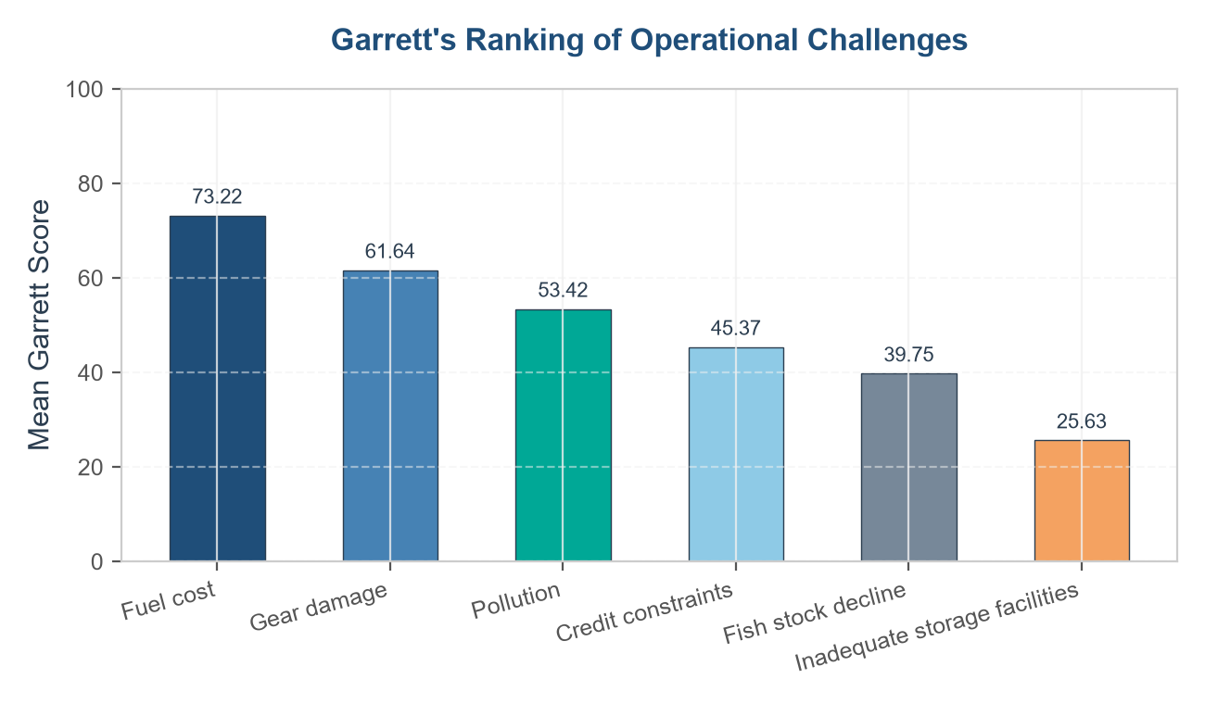

- Financial Performance and Input Cost Analysis
Distribution of Respondents Based on Average Selling Price of Fish per kg
Range | Selling Price Bracket (GHS) | Frequency | Percentage %
Extremely Low (< 30 GHS) | 1 | 0.8%
Very Low (30 to 44 GHS) | 5 | 4.2%
Low (45 to 59 GHS) | 43 | 36.4%
Moderate (60 to 74 GHS) | 37 | 31.4%
High (75 to 89 GHS) | 29 | 24.6%
Very High (90 to 104 GHS) | 2 | 1.7%
Extremely High (105 GHS and above) | 1 | 0.8%
Total | 118 | 100.0%

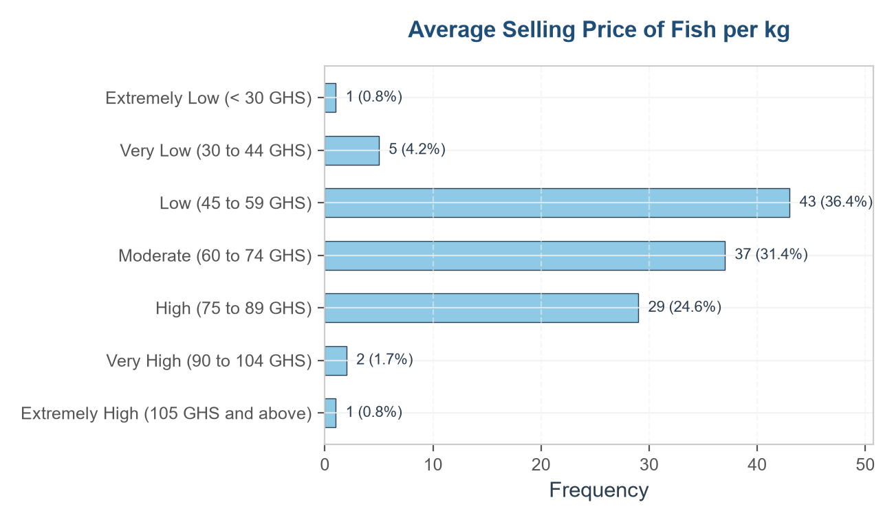

Income Sufficiency Category | Frequency | Percentage %
Good/Very Good (Sufficient) | 21 | 17.8%
Average (Stagnant) | 38 | 32.2%
Poor/Very Poor (Declining) | 59 | 50.0%
Total | 118 | 100.0%

Mean Price (GHS) | Median Price (GHS) | Minimum Price (GHS) | Maximum Price (GHS) | Standard Deviation (GHS)
64.74 | 64.50 | 5.00 | 200.00 | 19.53

- Influence of Operational Costs on Fishing Performance
Average Monthly Expenditure on Gear Repair/Maintenance (GHS)
Gear Repair Expenditure (GHS) | Frequency | Percentage %
< 300 GHS | 24 | 20.3%
300 - 399 GHS | 18 | 15.3%
400 - 499 GHS | 25 | 21.2%
500 GHS and above | 17 | 14.4%
Not Applicable | 34 | 28.8%
Total | 118 | 100.0%

Average Weekly Fish Catch Bracket (kg)
Weekly Catch Bracket (kg) | Frequency | Percentage %
< 150 kg | 18 | 15.3%
150 - 249 kg | 41 | 34.7%
250 - 349 kg | 34 | 28.8%
350 kg and above | 25 | 21.2%
Total | 118 | 100.0%

Average Weekly Expenditure on Fuel Bracket (GHS)
Weekly Fuel Cost (GHS) | Frequency | Percentage %
< 500 GHS | 17 | 17.7%
500 - 699 GHS | 24 | 25.0%
700 - 899 GHS | 26 | 27.1%
900 GHS and above | 29 | 30.2%
Total | 96 | 100.0%

Household Size of Respondents (Alternative Grouping)
Household Size Group | Frequency | Percentage %
1 - 2 | 24 | 20.3%
3 - 4 | 39 | 33.1%
5 - 6 | 39 | 33.1%
7 and above | 16 | 13.6%
Total | 118 | 100.0%

Years of Fishing Experience Bracket
Fishing Experience (Years) | Frequency | Percentage %
< 10 years | 30 | 25.4%
10 - 14 years | 25 | 21.2%
15 - 19 years | 21 | 17.8%
20 - 24 years | 23 | 19.5%
25 - 30 years | 19 | 16.1%
Total | 118 | 100.0%

Access to Cold Storage Facilities
Cold Storage Access | Frequency | Percentage %
Yes | 29 | 24.6%
No | 89 | 75.4%
Total | 118 | 100.0%

Reinvestment of Fishing Revenue
Reinvests Fishing Revenue | Frequency | Percentage %
Yes | 100 | 84.7%
No | 18 | 15.3%
Total | 118 | 100.0%

Overall Rating of Current Fishing Income
Current Income Rating | Frequency | Percentage %
Very poor | 18 | 15.3%
Poor | 41 | 34.7%
Average | 38 | 32.2%
Good | 18 | 15.3%
Very good | 3 | 2.5%
Total | 118 | 100.0%

Rating of the Cost of Fishing Equipment and Inputs
Equipment Cost Rating | Frequency | Percentage %
Very low | 2 | 1.7%
Low | 9 | 7.6%
Moderate | 34 | 28.8%
High | 54 | 45.8%
Very high | 19 | 16.1%
Total | 118 | 100.0%

